***­­Lab 1 - ASP.NET program using Entity Framework***

*Steps to perform the Task:*

*Create a New ASP.NET Web Forms Application:*

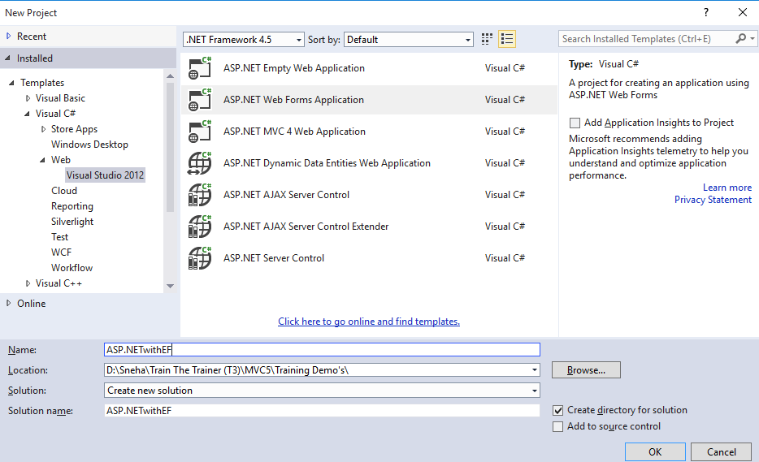

*Add SQL Server Database and create the following Table:*

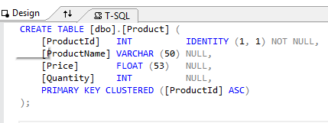

*Create a Store Procedure for Searching and Loading Product details as follows:*

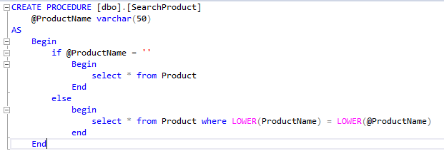

*Add ADO.NET Entity Data Model to the Project. Select EFDesigner from database > Click on Next > Click on Next > Select the necessary Tables > Click on Finish.*

*The following will appear:*

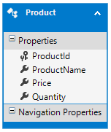

*Goto Model Browser and Check the SearchProduct Stored Procedure under Function Imports.*

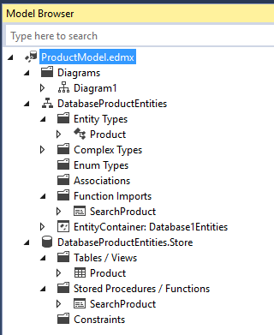

*Right click on the SearchProduct and goto properties. Change Return Type from Complex to Entities and select Product from the dropdown list and click OK.*

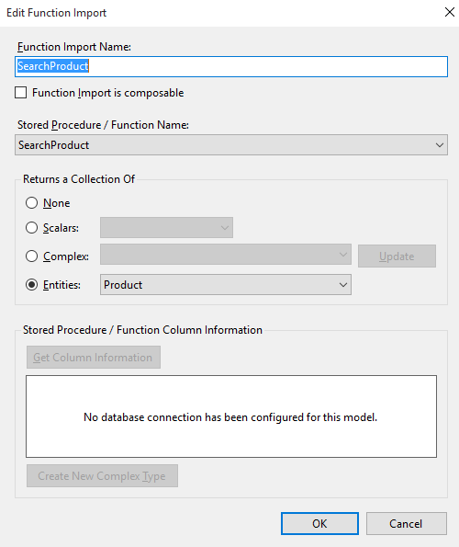

*Add WebForm and Create the following design to perform Insert, update, delete and Search operations:*

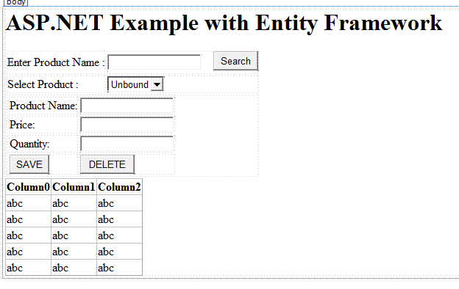

*Create two methods called ClearForm and PopulateProductList for clearing the form and loading into the grid view.*

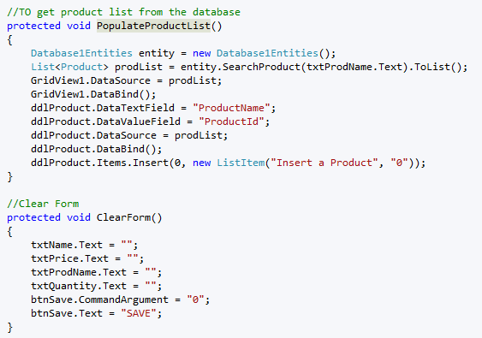

*Code for Search button:*

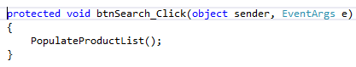

*Code for page load method:*

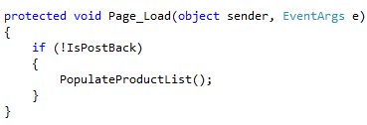

*Code For Selected Index Change of Dropdown List, Please note: set the AutoPostBack attribute as true for Dropdownlist*

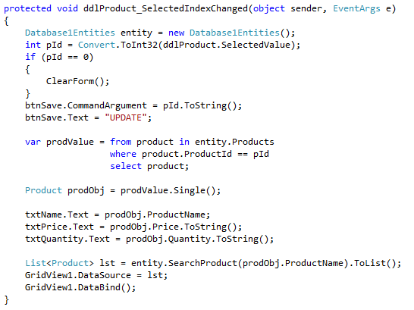

*Code for Save Button:*

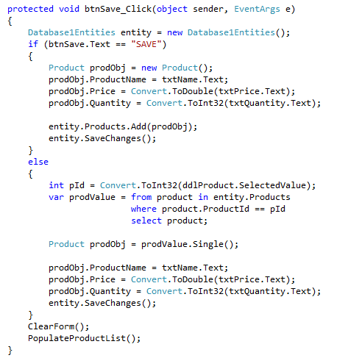

*Code for Delete Button:*

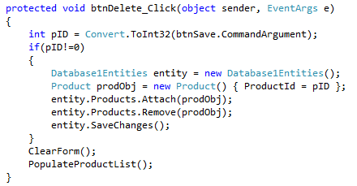

*Implementing the stored procedures for searching records:*

*Create a stored procedure:*

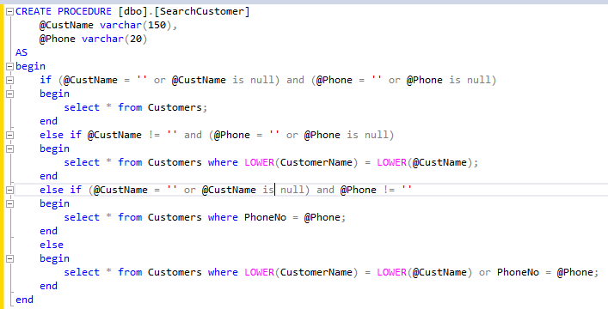

*In the Index.cshtml of CustomersController add the following code:*

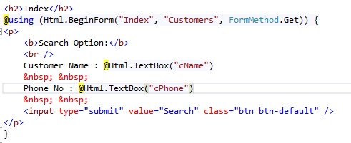

*Goto model browser of CustomerModel.edmx. Right click on CustomerModel.Store and Click Update model from Database.*

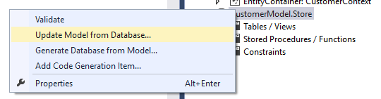

*Under Add tab select Stored Procedure and click on Finish Button. In the model browser now click on SearchCustomer Function and select properties.*

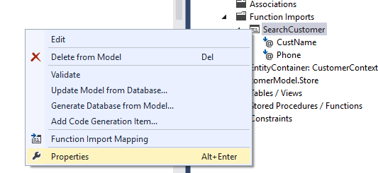

*Change the return type by click on the … Button*

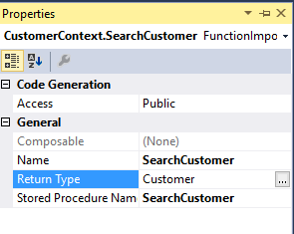

*Select Entities radio button > Select Customer from the drop down list > Click OK button*

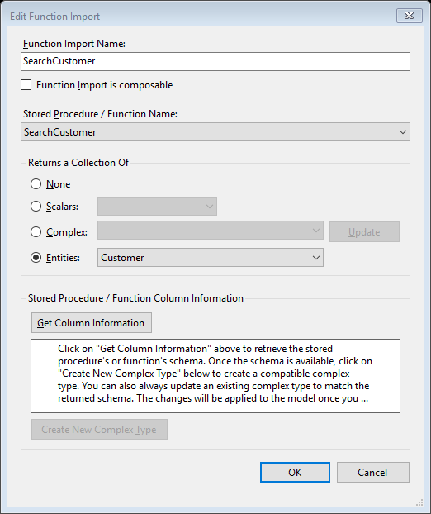

*Make the following modification in the CustomersController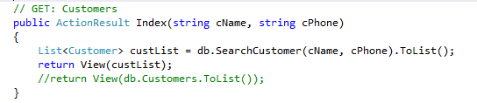*

*Now when u execute the output will be:*

**